PROJECT START-UP YOUTH
with contributions

ADMISSION RULES AND OPERATION

Art. 1 - Objectives

t²i - technology transfer and innovation sc a rl realizes the project "START-UP YOUTH" (the hereinafter referred to Start Up), an initiative sponsored by the Foundation of the Savings Bank of Padua and Rovigo in collaboration with the Chamber of Commerce Rovigo Venice Lagoon.

In particular, one of the initiatives to be developed includes the possibility of making available of "young entrepreneurs" of physical space to use furnished office and a common set of services for the development of new businesses, with particular attention to technological innovation.

The equipped offices are assigned to all who are interested to avail of a home and a number of functional services to the constitution and the start of their own business venture; some services are included as part of "Start Up" and then will be offered to users free of charge, other services will instead be offered at a discounted rate.

This Regulation provides a brief description of the structure and the services offered. However relations between t²i and users will be regulated by a special agreement.

Art. 2 - Beneficiaries

They can apply for a Start Up admission is individuals that enterprises being established or already consist of no more than one year on the date of application.

Art. 3 - How to submit an application form

The application must be submitted exclusively using the downloadable form from the website (http://www.t2i.it/supporto-sviluppo-idee-impresa/incubatore-dimpresa/) In the section dedicated to the "Support and development of business ideas / business incubator".

All documentation (application admission, curriculum vitae of the project participants and business-business plan) should be forwarded by the interested parties, possibly via e-mail in pdf format complete the required signatures, or handed in at the secretariat.

The application may be submitted at any time after the publication of this Regulation.

Art. 4 - Evaluation of applications
The applications consist of three basic documents:

- Admission request;

- business project - business plan;

- Curricula participants.

t²i will evaluate the applications submitted by expressing one of the following evaluations.

 | criteria evaluation | Rating | Outcome
 | 1. In order of | 1. ALLOWED | clear and complete Question
 |  |  | The entities can become all users effects of Start Up
 | presentation
 | 2. Feasibility idea | 2. SUSPENDED | Interesting question, but not sufficiently clear and complete
 |  |  | or with business prospects uncertain.
 | 3. Capacity embodiment |  | The entities are invited to resubmit the integrated application
 |  |  | and thorough.
 | of / the proposer / s
 |  | 3. REFUSED | Question with serious flaws.
 | 4. Age |  | The entities are encouraged to apply again not before
 |  |  | 3 months

Art. 5 - Time and Conditions stay

For users to remain in the incubator will be through a yearly, renewable contracts.

Users can avail the services even before formally constitute the enterprise and in any event within three months of arriving, users must form the company / undertaking. If the company is not formed, at the end of the period, it will end their stay at Start Up.
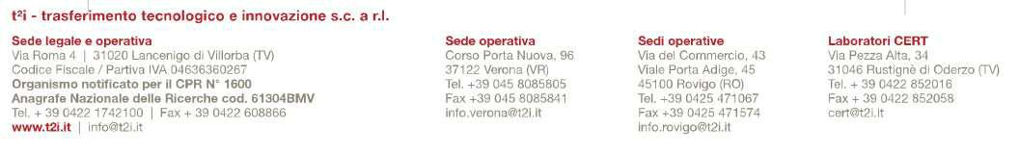

Art. 6 - Services

Start Up will provide you with certain services, aimed at the creation and startup of the newly established enterprises.

offices are equipped with a variable size between 19 m and 34 m.
Some services are provided, included in the rent, other extra-fees at special rates.
Reports will be governed by special agreements.
The services included in the rent include:
use of a space, assigned in accordance with the user, of different sizes, already furnished and arranged with electrical connections and telematic connections

# 1 printer / color scanner

n. 1 personal computer connected to the network printer b / n. 1 high-speed Internet line

secretarial service, switchboard and reception

cleaning of premises, heating, cooling and electricity Telephone / inbound fax service

use of common areas

use of meeting rooms by reservation mail sorting incoming
web space into a section of the site t²i No max. 3 pages of neo enterprise incubated

During start up business

before setting the three-year business plan

supervision of the implementation of the business plan through personalized advice from a business mentor

consulting voucher of industry analysis and market research

funding opportunities (door micro-credit, support the access of facilities for

youth and female entrepreneurship, etc.)
The extra fee at a discounted rate services include:

costs of consumables related to printer and photocopier in the common areas postage

edit and print documents telephone / fax output
use conference room for seminars / trainings and workshops

administrative and accounting, bookkeeping, preparation of financial statements

consulting for the preparation of applications for obtaining of loans and grants patents and trademarks

complete draft of the business plan for further funding / grants building websites

services of testing and certification

Anything not specified in this Regulation for a fee.

Art. 7 - Consideration

The size of the offices varies from 19 square meters to 34 square meters (some offices provide more workstations).
The consideration must be agreed from time to time depending on the office floor area chosen.

Any costs of accommodation spaces and maintenance are borne by STARTUP-INCUBATOR provided previously agreed and authorized.

Art. 8 - Validity of this Regulation

This Regulation has no expiry date and can be changed at any time by t²i which will publish it on its website in the section START UP

This Regulation is published in Rovigo on 01/01/2017

