

PROGETTO START-UP GIOVANILE

Spett. le
t²i – trasferimento tecnologico e innovazione s.c. a r.l.
VIA DEL COMMERCIO 43
45100 ROVIGO

Object: PROJECT START-UP GIOVANILE
Application Form Corporate Incubator

Hereby, you are asked to participate in the Business Incubator of “t2i”, transmitting the following documents:

- BUSINESS PLAN
- CURRICULUM VITAE of all participants in the project

declaring to accept the contents of ADMISSION AND OPERATION REGULATION aware that sending this, equates to subscribe for all the documentation sent electronically.
If the project were successful, the undersigned/s, before the project starts, will provide to deposit at the t²i’s offices an original copy signed of all the documentation submitted.

Care is taken to report the following name as a contact person to turn to for the project.
First and Last Name of contact person
Address Cap/City
Tel. cell. e.mail
C.F. VAT number

It also declares that was read the following CONFIDENTIALITY CLAUSE:
“t²i (hereinafter Company) is committed to ensuring the confidentiality and not to make available or otherwise disclose to third parties the data and / or information of an economic and / or commercial and technical (know-how), communicated with this business plan they are to be confidential, and have been indicated as "reserved." This commitment does not include details and / or publicly available information and / or have already spread and in any case already available to third parties. The Company may in any event disclose any details derived from the business plan for statistical purposes and in general for all the institutional purposes of the project, with forms and methods that guarantee full respect of the confidentiality above. "

Date and signature of the project contact person __________________________


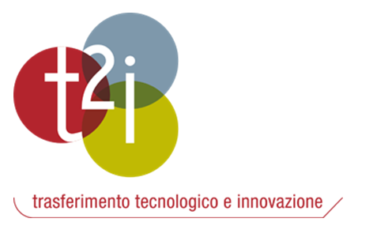
Con il contributo

